**Software**

**Testing**

**Medwle Android Application**

**Group Members:**

**Aetukuri Srinath - U101116FCS005**

**Rakshith Reddy - U101116FCS099**

**Abhinav Reddy - U101116FCS003**

**Gowtham Varma - U101116FCS028**

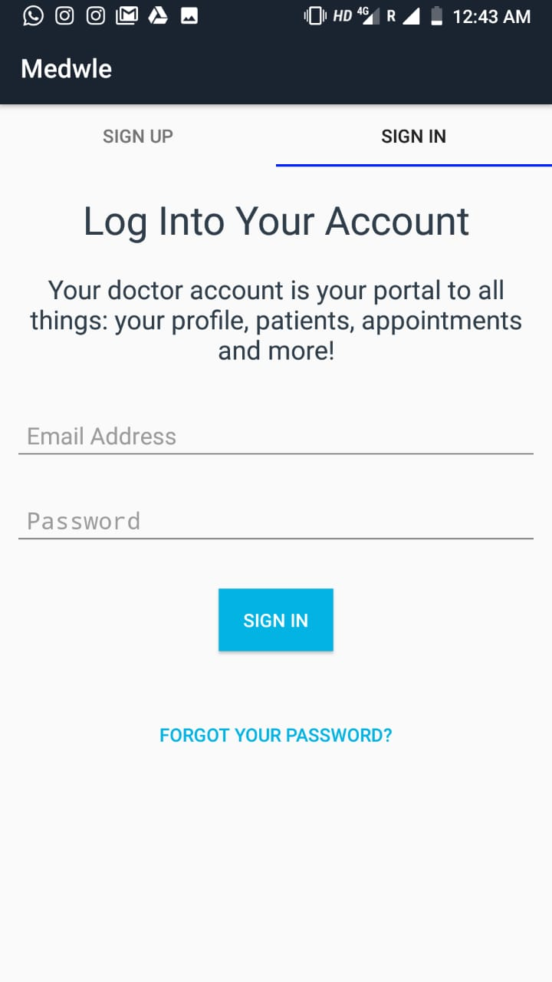

**Expected Working:**

1. Figure A shows the splash screen (first boot up screen) of the application.
2. After a delay of 3 seconds the app should load to the screen displayed in Figure B (Main Patient Login Screen)

* **Behavior On testing:**

1. As expected the splash screen comes for 3 seconds, and then the main login screen is displayed.
2. The app closes normally on back press.

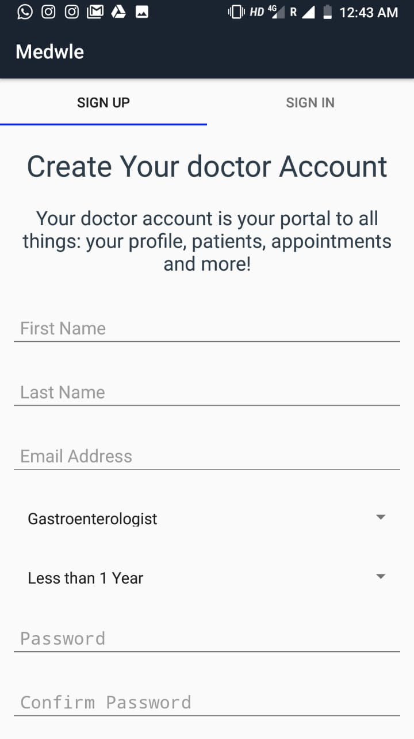

* **Expected Working:**

1. Figure A shows the main login screen (for patient).
2. If the Email and Password fields are left blank, then an error pops

Up in the text boxes, and the login fails.

1. In case email and password fields are filled with valid text then there is no error.

* **Behavior On testing:**

1. As expected on leaving the email and password fields blank, we receive a red pop up error.
2. If the Email and password fields are filled up with valid type of data then there is no error.
3. The app closes normally on back press.

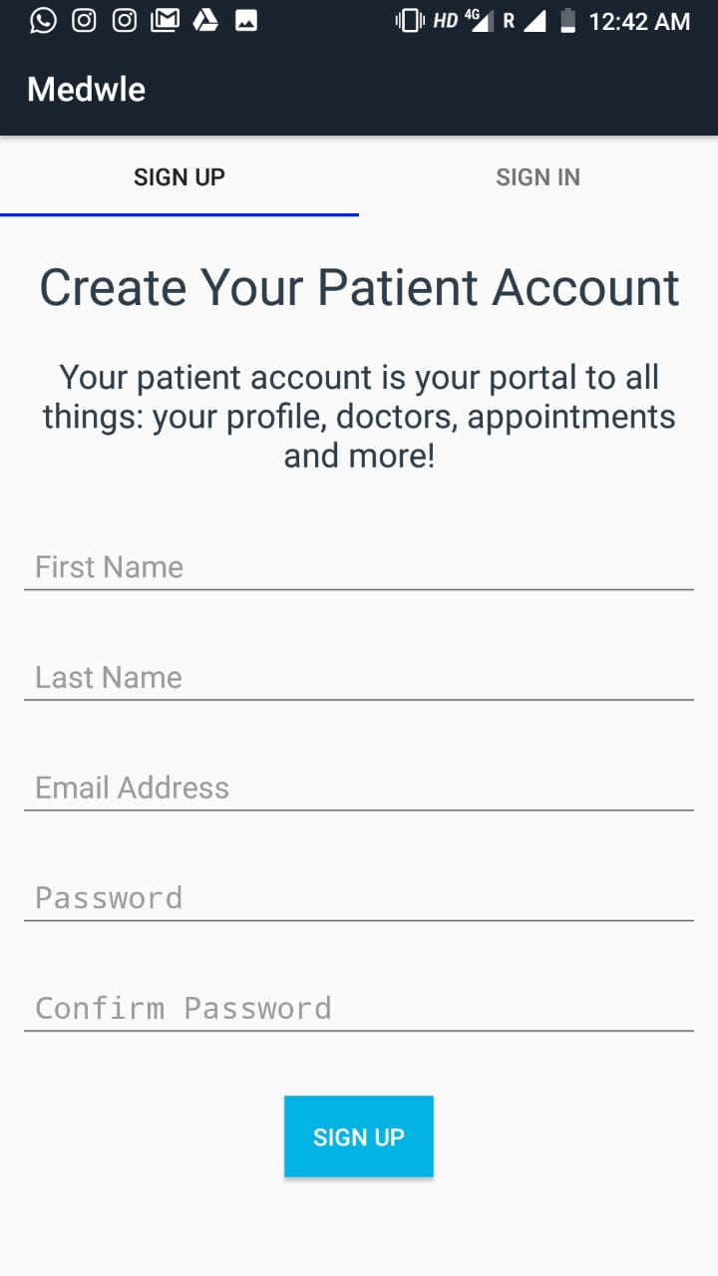

* **Expected Working:**

1. Figure A shows main login screen (for patient).
2. On entering valid, email id and password and clicking on the submit button, the request to login is processed on the Server

(Firebase).

1. If Details of the user match then Figure B is opened as the new Screen, where the profile details of the user are displayed**.**

* **Behavior On testing:**

1. On entering valid email id and password, the user was logged in.
2. The Patient profile fragment was loaded automatically as expected.
3. On back press , user is not logged out, until done manually

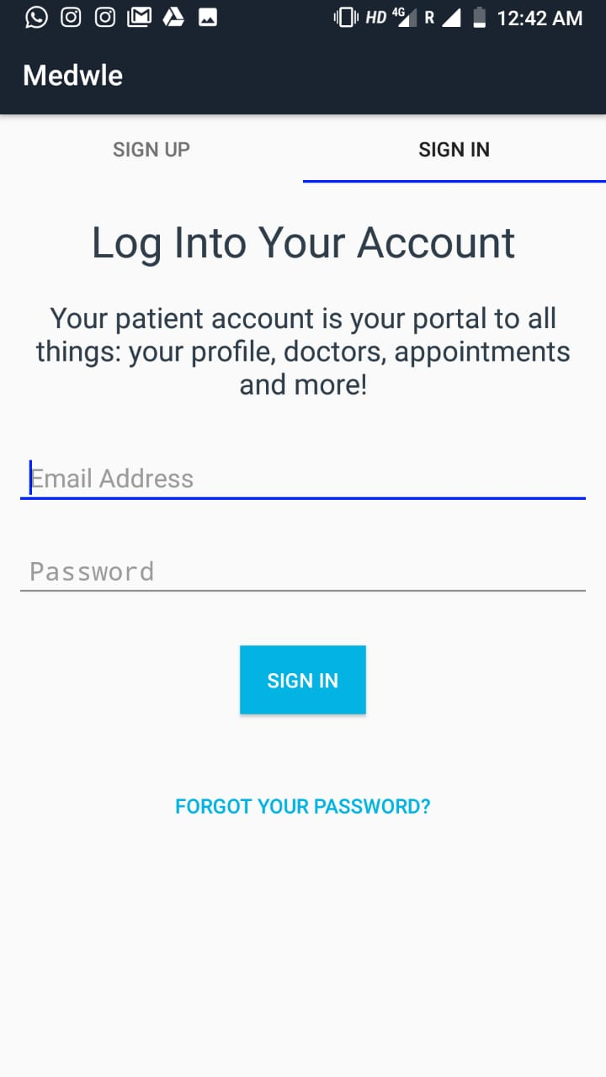

* **Expected Working:**

1. After Successful login, user profile must be displayed.
2. User can edit/update his or her profile by clicking on the UPDATE PROFILE button as shown in Figure A

* **Behavior On testing:**

1. As expected, on clicking the UPDATE PROFILE button in Figure A, it leads us to the screen shown in Figure B, where user can edit his/her basic profile information.
2. On pressing The UPDATE PROFILE button in Figure B, we lead back to the Profile Fragment , with updated data.



* **Expected Working:**

1. Figure A shows the screen to update user details.
2. After filling in the new details, the UPDATE PROFILE button is pressed.
3. The Profile opens up with the updated details.

* **Behavior On testing:**

1. Output occurs as expected, on pressing the UPDATE PROFILE button, the new details are loaded back onto the Profile fragment.

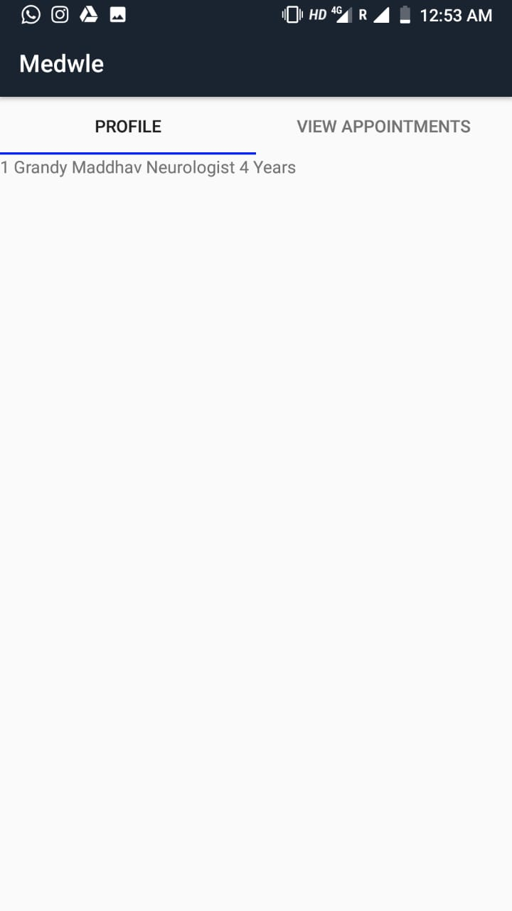

* **Expected Working:**

1. In the book appointment fragment, user is asked to enter date and time of the appointment.
2. On clicking the SUBMIT, an appointment is submitted on the server.

* **Behavior On testing:**

1. As processes take place as expected.
2. On back press, the app closes without data loss.

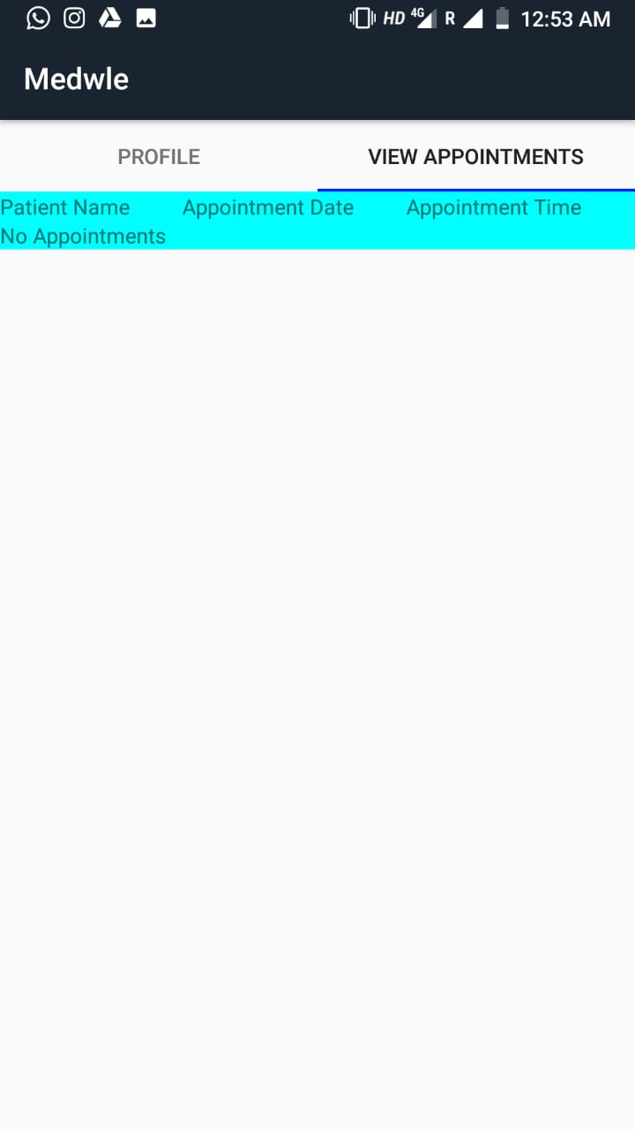

* **Expected Working:**

1. There is a Logout option in the menu as shown in Figure A.
2. Clicking the logout button leads us back to the login screen.

* **Behavior On testing:**

1. As expected, clicking on the logout button leads us back to the login screen.
2. On back press the app closes normally.

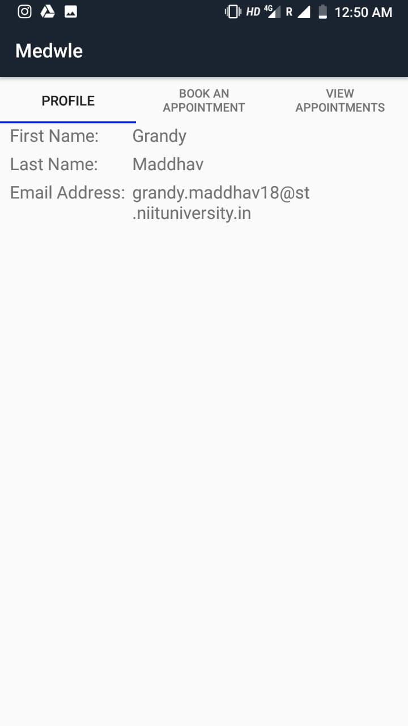

* **Expected Working:**

1. Figure A shows the main login screen
2. There is a menu option in the menu bar, to select to login as a doctor.

* **Behavior On testing:**

1. As expected, clicking on the logout button leads us back to the login screen.
2. On back press the app closes normally.

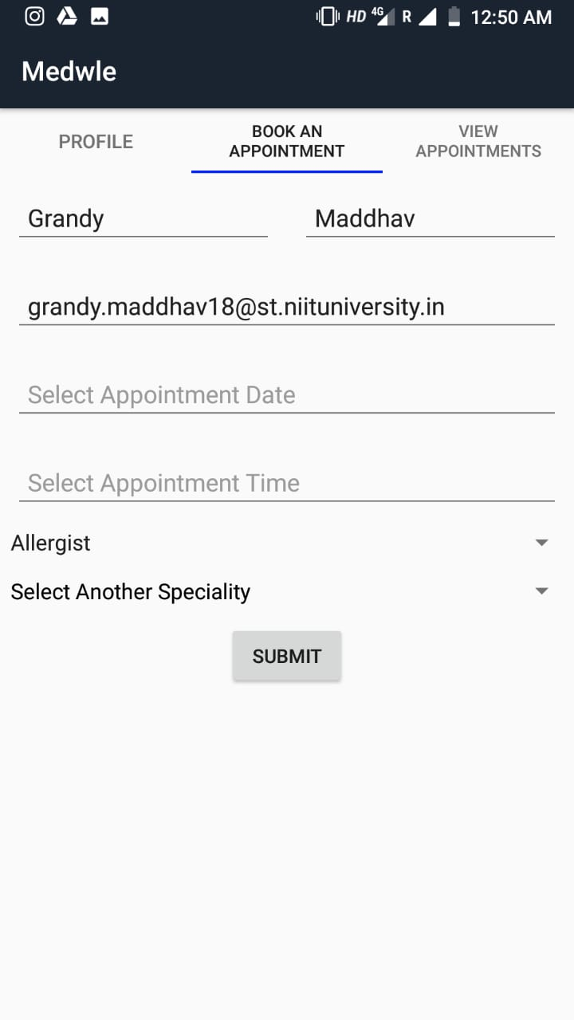

* **Expected Working:**

1. Figure A shows doctor login screen.
2. If the email and password are not valid, an error pops up.
3. If email and password are valid, successful login opens up a new activity, with the list of patients and list of appointments.

* **Behavior On testing:**

1. All events take place as expected.